

# Project Proposal

**Department of CIS Course code: CIS 232 & 232L Course title: Operating Systems**

# Semester: Fall 2023

|  |  |
| --- | --- |
| **Submitted By** | **Submitted To** |
| Md. Sami Alam  ID: 222-16-656  Department of CIS | Ms. Sonia Nasrin Lecturer Department of CIS |

**Due date: 4/09/2023 Submission date: 5/09/2023**

**Project Title**

## “Bus Reservation system”

Linux based Bus reservation system.

**Background**

"Bus Booking" is a popular system that helps people to reserve bus tickets to different places. But the old way of buying bus tickets in person at ticket counters has become inconvenient for both passengers and the company. There are long lines, lots of paperwork, and sometimes it's hard to get a ticket when many people want to travel.

To make things easier, Bus has decided to create a new system using a special computer language called shell script on a computer that runs Linux. This system will let people book bus tickets using their computers or phones without going to a ticket counter. It will be like chatting with a computer, and it will be easy to use, kind of like sending text messages. This system will use some computer tricks like making decisions, keeping lists, and working with words. The goal is to make booking bus tickets much simpler for everyone and get rid of the hassle of waiting in long lines or worrying about tickets running out, especially when a lot of people want to travel.

**Functionalities of the System**

**User interactions:** User interactions will involve utilizing a command line interface where users execute predefined Linux scripts to operate the desired Bus reservation System**.**

**Menu:**

In that section, the user will be able to select the options from a menu. Here will be some options like Login System, booking of tickets, cancel tickets, Checking bus status, etc.

**Login System:**

The Login System allows registered users to log in to their accounts securely. Users typically need to provide their username and password to access the system. This functionality ensures that only authorized users can book or cancel tickets and check bus statuses.

**Booking of Tickets:**

The Booking of Tickets functionality enables users who are logged in to search for available buses, select their desired routes, specify the number of tickets they want to purchase, and choose their preferred seats if available. Once the booking details are confirmed and payment is processed, the system reserves the seats and generates booking confirmations and e-tickets for the passengers.

**Cancel Tickets:**

The Cancel Tickets feature allows users to cancel their previously booked tickets if their travel plans change. Users provide their booking information or reference number, and the system processes the cancellation, following the company's cancellation policy. Refunds, if applicable, are also processed through this functionality.

**Checking Bus Status:**

Checking Bus Status functionality provides users with real-time information about the status of buses. Users can inquire about the availability of buses on specific routes, departure and arrival times, the number of seats remaining, and any delays or schedule changes. This information helps passengers plan their journeys effectively.

**Total tk after reserving:**

In a bus reservation system or similar service, "Total tk after reserving" refers to the total cost or amount of money that a passenger needs to pay after making a reservation or booking for one or more seats on a bus.

**Exit the System:** the user can leave the bus ticket reservation system when he or she want.

**Pseudocode**

**UML**

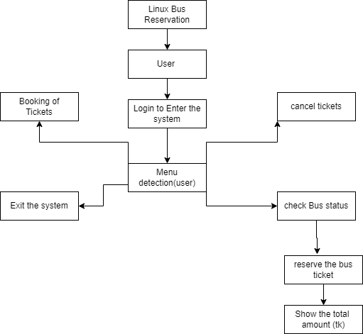

**Required Tools**

Device (PC or Laptop):

Windows 11 HP EliteBook 840g5

Programming Language: Shell scripting(bash)

Development Environment:

* A Linux-based operating system (windows) for testing and execution.
* Text editor or IDE for shell scripting.

# Conclusion

In the end, the Bus Booking system is designed to simplify the process of reserving bus tickets by replacing the traditional in-person ticket counter with a user-friendly shell script-based interface on Linux. This modernization aims to eliminate long queues, reduce paperwork, and ensure ticket availability even during peak travel times. The system offers functionalities such as user login for secure access, booking and canceling tickets, checking bus statuses in real-time, and providing the total cost after reserving seats. Overall, the Bus Booking system is a convenient and efficient solution for passengers and the bus company alike, making bus travel more accessible and hassle-free.